**Project Details**

|  |  |
| --- | --- |
| **Project Code:** |  |
| **Project Name:** | OneGP - Budget Planning |
| **Account:** | GrameenPhone |
| **Location:** | Bangladesh |
| **Customer Name:** | GrameenPhone |
| **Delivery Head/ Email ID:** |  |
| **Program Manager / Email ID:** |  |
| **Quality Coordinator / Email ID:** |  |
| **Customer Contact Information:** |  |
|  |
| Basundhara, Dhaka, Bangladesh |

|  |  |  |  |  |
| --- | --- | --- | --- | --- |
| Mohammad Al-Nur Sarwer Arif, 27/09/2022 |  |  |  |  |
| **Prepared by/Date** |  | **Reviewed by/Date** |  | **Approved by/Date** |

**Revision History**

|  |  |  |  |  |  |
| --- | --- | --- | --- | --- | --- |
| **Version (x.yy)** | **Date of Revision** | **Description of Change** | **Reason for Change** | **Affected Sections** | **Approved By** |
|  |  |  |  |  |  |
|  |  |  |  |  |  |
|  |  |  |  |  |  |
|  |  |  |  |  |  |
|  |  |  |  |  |  |
|  |  |  |  |  |  |
|  |  |  |  |  |  |
|  |  |  |  |  |  |

**List of Reference Documents**

|  |  |
| --- | --- |
| **Name** | **Version No.** |
|  |  |
|  |  |
|  |  |
|  |  |

## ***Introduction***

This module is a new module of OneGP. The name of the module is Budget Planning. From the OneGP application, employees of technology can raise budget plan requests providing the information of year, budget head, amount(BDT), amount(USD), project name and stakeholder lead. Employees can also upload budget request data in bulk. After the application is submitted successfully, employees or forum members will be able to see the request. Employees can add forum members by submitting their name and section. Forum members will edit budget requisition and will set budget code for each budget head, which is called budget lock and all history will be captured. After budget lock employee will plan date wise ordering and will edit budget requisition and all history will be captured. After budget lock employee will plan date wise capitalization and will edit capitalization plan and all history will be captured. Employees can raise purchase request (PR) providing the information of PR number, PR date, PO number, PO issue date, amount(BDT), amount (USD), PR description, tentative capitalization date. PR amount should not exceed remaining budget amount. Employees can raise capitalization by providing the information of the respective PO number, capitalization amount, date, Coupa/SRT reference. Capitalization amount should not exceed remaining PO amount. Employees or forum users can carry forward any amount from previous year.

## ***Scope***

1. Master Data Management
   1. Budget Requests
      1. Admin can view budget request related information.
      2. Admin can search budget request related information by the name of an employee, section, year.
2. Budget Plan Requests
   1. Budget Requests
      1. Employee can add/edit budget plan request.
      2. To raise a request for new budget request, an employee should provide the information of year, budget head, amount(BDT), amount(USD), project name and stakeholder lead.
      3. Employee can transfer budget plan request.
      4. Employee can drop budget plan request.
      5. After the application is submitted successfully, employees or forum members will be able to see the request.
      6. Admin can search budget request related information by the name of an employee, section, year.
      7. Employees can search budget request related information by the name of an employee, section, year.
   2. Bulk Request
      1. Employees can also upload budget request data in bulk.
   3. Carry Forward
      1. Employees or forum users can carry forward any amount from previous year.
3. Forum Members
   * 1. Employees can add forum members by submitting their name and section.
4. Budget Lock
   * 1. Forum members will edit budget requisition and will set budget code for each budget head, which is called budget lock and all history will be captured.
     2. After budget lock employee will plan date wise ordering and will edit budget requisition and all history will be captured.
     3. After budget lock employee will plan date wise capitalization and will edit capitalization plan and all history will be captured.
5. Purchase Request (PR)
   * 1. Employees can raise purchase request (PR) providing the information of PR number, PR date, PO number, PO issue date, amount(BDT), amount (USD), PR description, tentative capitalization date.
     2. PR amount should not exceed remaining budget amount.
6. Capitalization
   * 1. Employees can raise capitalization by providing the information of the respective PO number, capitalization amount, date, Coupa/SRT reference. Capitalization amount should not exceed remaining PO amount.
     2. Bulk capitalization upload for forum members (excel).

## **Design Description**

3.1 **Business Process Design**

Below figure: 01 represents the whole business process of IExpense.

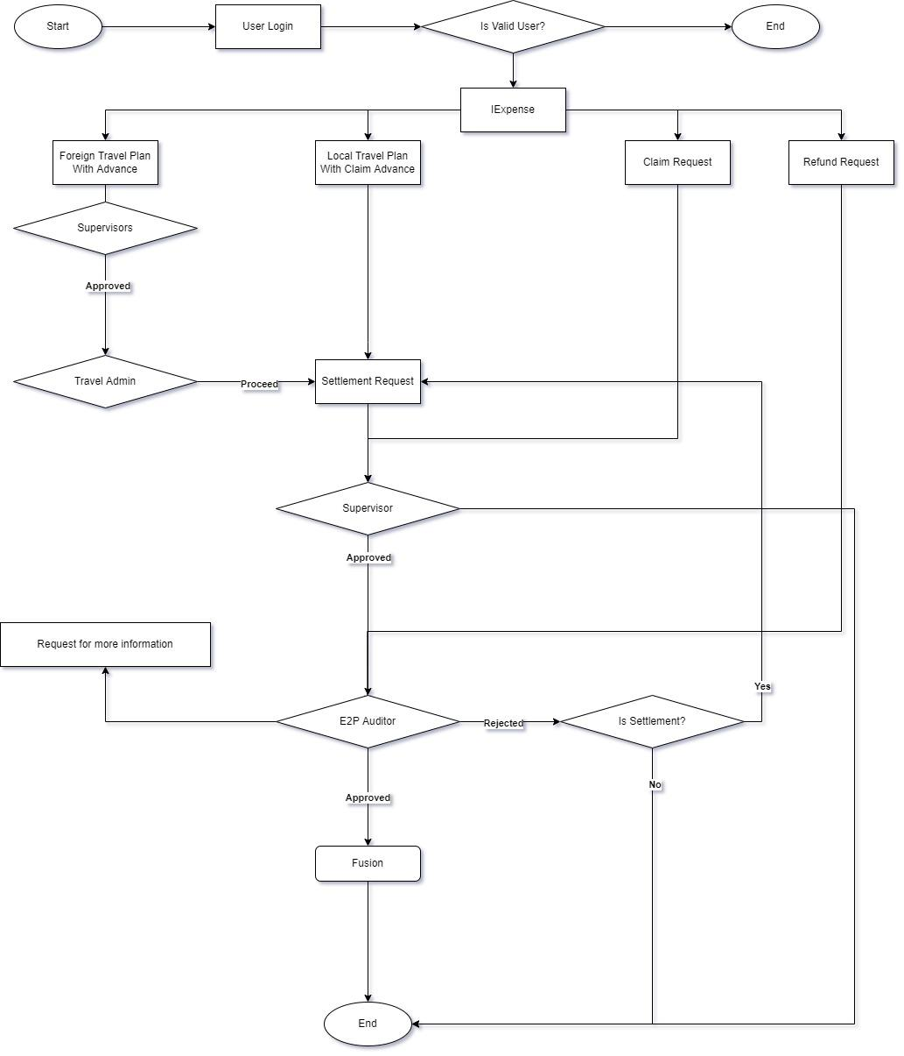

**Figure 01: Business process of iExpense**

**3.2 Database Diagram**

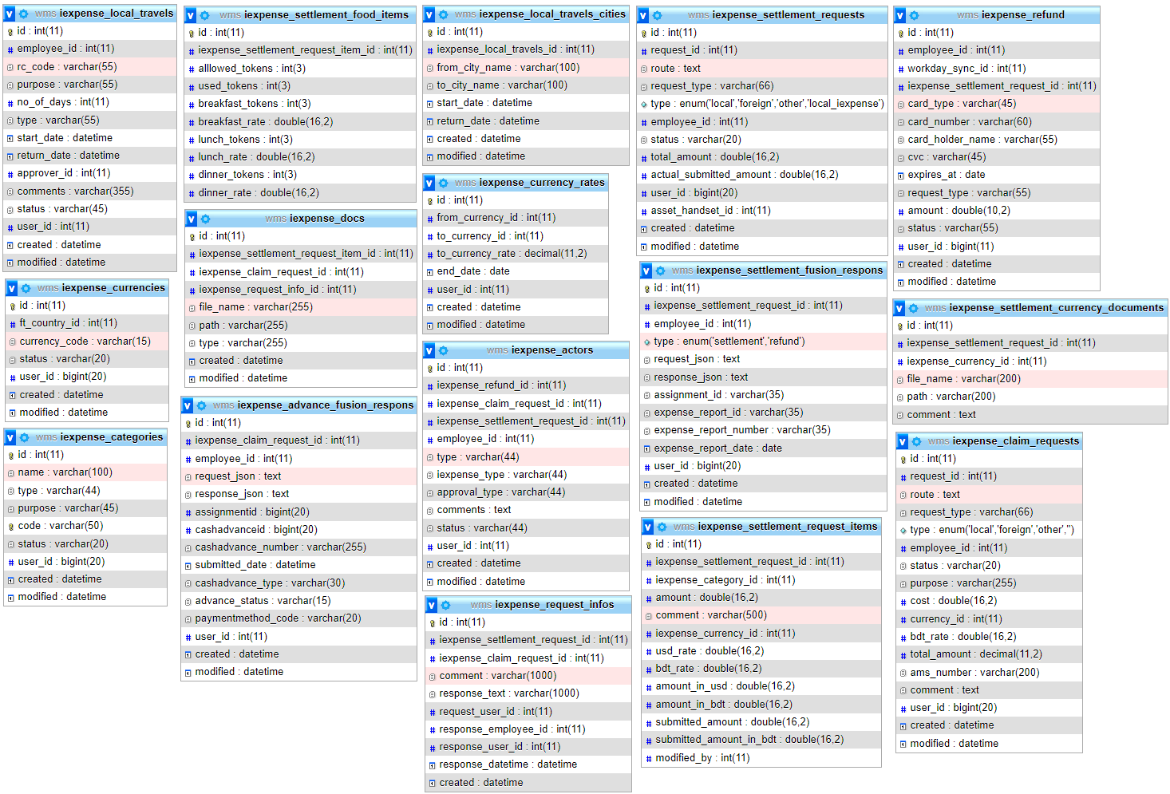

**Figure 02: Database Diagram**

**3.3 Unified Model Diagram**

**3.3.1 Class Diagram**

**Class diagram for iExpense (Android)**

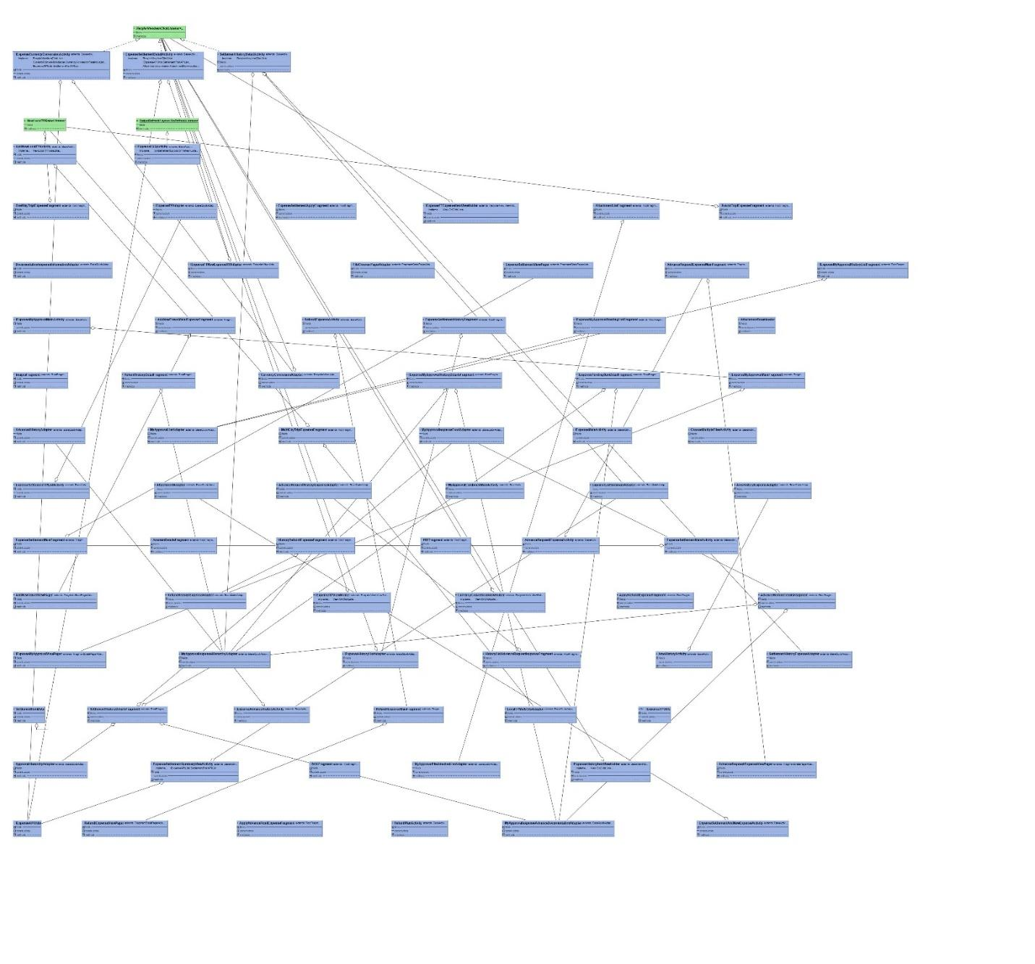

**Figure 3.3.1: Class Diagram for IExpense (Android)**

**3.3.2 USE CASE Diagram for IExpense**

**Figure 3.3.2: Use Case Diagram**

**3.3.3 Sequence Diagram**

**3.3.3.1 Sequence diagram for iExpense**

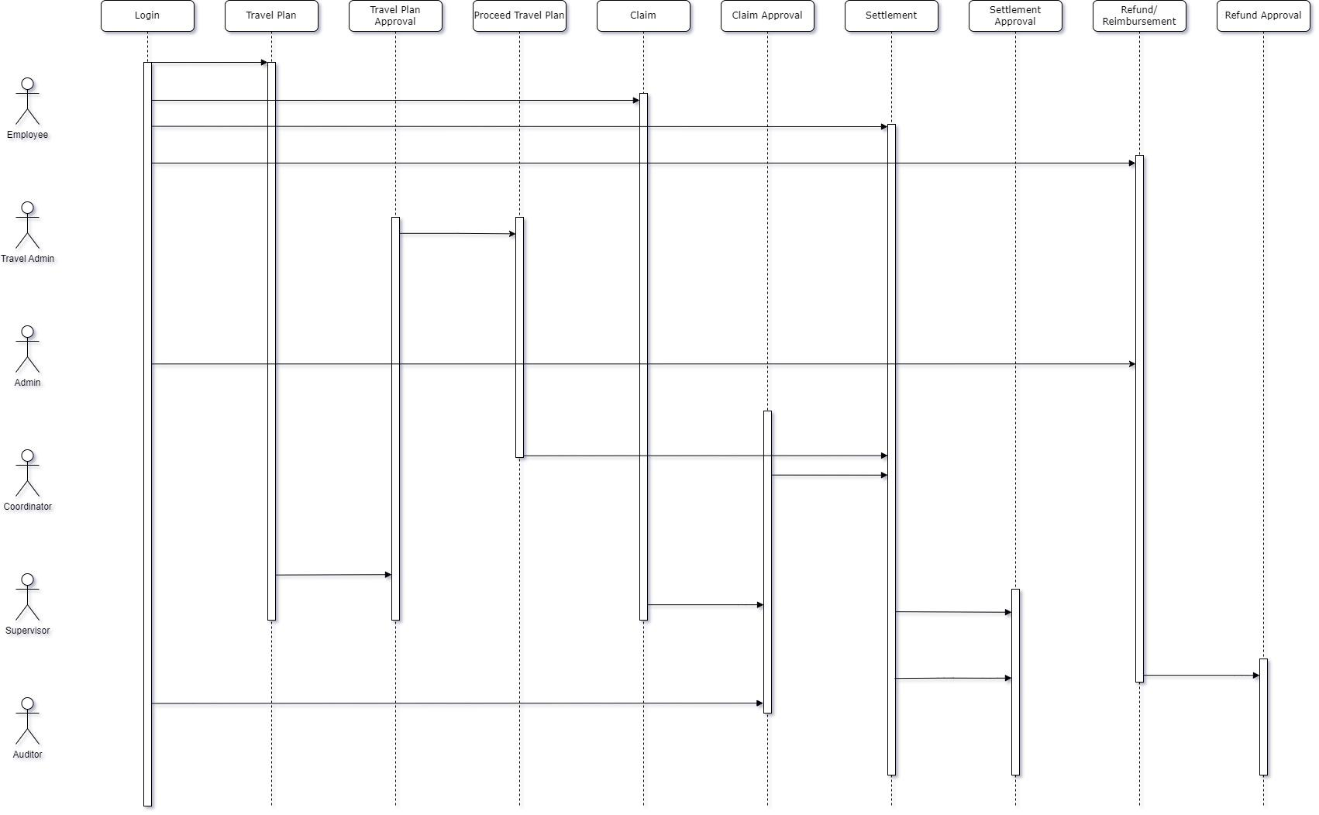

**Fig 3.3.3: Sequence diagram for iExpense**

**3.4 Prototype Design**

**3.4.1 Travel Plan and Advance Claim**

For this module, the Employee can raise a travel plan along with that request for an advance. There are three types of claims. Local, foreign, and other advances. And can plan for foreign and local.

**3.4.1.1 Process Flow**

**Web:**

**Local Travel:**

* 1. Login to OneGP web application
  2. Employees can request an advance for local travel from a local travel plan from IExpense -> Employee -> Local Travel Plan.
  3. An employee can add one/multiple local travel after going to IExpense -> Employee -> Local Travel Plan->New Local Travels. Then the employee must provide proper information and click the submit button to confirm local travel. The local travel will set in a particular date or within a date range. departure city and destination city will be auto populated in the expense settlement.
  4. Employees can edit local travel mini or local travel plan before the expense settlement’s approval.
  5. While editing local travel an employee can add/edit/delete hotel and ticket. After any changes in adding hotel/ticket or editing hotel/ticket, it will be returned to travel bucket.
  6. Place a settlement request from IExpense->Employee->LT Settlement request against the plan. Settlement in draft state can be editable.
  7. Approver can approve or reject the request.
  8. After the approvement from the approver, an auditor approves or rejects the advance from IExpense -> E2P Auditor or can edit the advance. But the advance amount couldn’t be bigger the number employee claimed and attachment will be replace if auditor submit one.

**3.4.1.1.1 DB Operation**

|  |  |
| --- | --- |
| **Table Name** | **Change Type** |
| wf_issues | Old Table |
| wf_workflow_transitions | Old Table |
| travel_tickets | Old Table |
| travel_accomodations | Old Table |
| iexpense_settlement_requests | Old Table |
| iexpense_settlement_request_items | Old Table |
| iexpense_settlement_food_items | Old Table |
| iexpense_docs | Old Table |
| iexpense_actors | Old Table |
| iexpense_settlement_currency_documents | Old Table |
| iexpense_request_infos | New Table |
| iexpense_settlement_fusion_respons | Old Table |

**Foreign Travel:**

* 1. Employees can request an advance for foreign travel from a foreign travel plan from Foreign Travel -> My Requisitions
  2. After completing all approvement of employee’s approvers Foreign Travel request goes to the travel admin’s list where the travel admin proceeds with the request and the foreign travel request goes for settlement.
  3. The advance amount is approved or rejected by the approver.
  4. After the approvement from the approver, an auditor approves or rejects the advance from IExpense -> E2P Auditor or can edit the advance. But the advance amount couldn’t be bigger the number employee claimed and attachment will be replace if auditor submit one.

**3.4.1.1.2 DB Operation**

|  |  |
| --- | --- |
| **Table Name** | **Change Type** |
| ft_actors | Old Table |
| ft_admin_docs | Old Table |
| ft_airports | Old Table |
| ft_cities | Old Table |
| ft_costs | Old Table |
| ft_countries | Old Table |
| ft_docs | Old Table |
| ft_expenses | Old Table |
| ft_hotels | Old Table |
| ft_passengers | Old Table |
| ft_requests | Old Table |
| ft_travel_cities | Old Table |
| Passports | Old Table |
| iexpense_settlement_requests | Old Table |
| iexpense_settlement_request_items | Old Table |
| iexpense_settlement_food_items | Old Table |
| iexpense_docs | Old Table |
| iexpense_actors | Old Table |
| iexpense_settlement_currency_documents | Old Table |
| iexpense_settlement_fusion_respons | Old Table |
| iexpense_request_infos | New Table |

**Other Settlement:**

* 1. Login to OneGP web application
  2. Place a new settlement request from IExpense->Employee->Other Settlement request.
  3. Approver can approve or reject the request
  4. After the approvement from the approver, an auditor approves or rejects the advance from IExpense -> E2P Auditor or can edit the advance. But the advance amount couldn’t be bigger the number employee claimed and attachment will be replace if auditor submit one.

**3.4.1.1.3 DB Operation**

|  |  |
| --- | --- |
| **Table Name** | **Change Type** |
| iexpense_settlement_requests | Old Table |
| iexpense_settlement_request_items | Old Table |
| iexpense_settlement_food_items | Old Table |
| iexpense_docs | Old Table |
| iexpense_actors | Old Table |
| iexpense_settlement_currency_documents | Old Table |
| iexpense_request_infos | New Table |
| iexpense_settlement_fusion_respons | Old Table |

**Other Advance:**

* 1. An employee can request other advances from IExpense -> Employee -> Advance Claim. Admin can request other advances on behalf of an employee from IExpense -> Admin -> Advance Claim
  2. The advance amount is approved or rejected by the approver.
  3. After the approvement from the approver, an auditor approves or rejects the advance from IExpense -> E2P Auditor or can edit the advance. But the advance amount couldn’t be bigger the number employee claimed and attachment will be replace if auditor submit one.

**3.4.1.1.3 DB Operation**

|  |  |
| --- | --- |
| **Table Name** | **Change Type** |
| iexpense_claim_requests | Old Table |
| iexpense_docs | Old Table |
| iexpense_actors | Old Table |
| iexpense_advance_fusion_respons | Old Table |

**Mobile:**

* 1. Login OneGP application via Android or IOS
  2. From navigation, the user can redirect the “Travel plan & Expense” module.
  3. To claim a request for local advance, the user can add a travel request with advance.
  4. To claim an advance request for foreign travel, the user can add a request from the foreign module with advance.
  5. To claim an advance request for any other purpose, the user can raise a request from the other advance section.
  6. After submitting a request successfully, the supervisor will be able to see the request and can Approve/Reject the request.
  7. After the supervisor’s approval, the auditor will be able to see the request and can Approve/Reject the request.
  8. The auditor requests more information to the employee raised the settlement if it’s necessary from the settlement detail.
  9. After the auditor’s approval, fusion will be called.
  10. From the web employee will be able to submit other advance claims for themselves.

**3.4.1.2 DB Operation**

|  |  |
| --- | --- |
| **Table Name** | **Change Type** |
| iexpense_claim_requests | Old Table |
| iexpense_advance_fusion_respons | Old Table |

**3.4.2 Settlement**

To use this feature, the user can settle the expenditure during his travel period.

**3.4.2.1 Process Flow**

* 1. A User needs to add the expense head, amount, and the billing document of expense
  2. The coordinator can do it on behalf of the user the employees tagged with him/her.
  3. If the user settles the request for foreign travel, he/she needs to attach all the currency documents and input the currency conversion rate.
  4. If the user doesn’t take the advance and needs to settle the expenditure of local travel, he can add a travel request from the local travel settlement section
  5. Local, Foreign and other settlements can only be submitted by the employee and by its coordinator from IExpense -> Coordinator menu
  6. Local travel settlement can be done multiple times.
  7. After submitting a request successfully, the supervisor can see the request and can Approve/Reject the request approve or reject the settlements from IEexpense -> Supervisor menu.
  8. After the supervisor’s approval, the auditor will be able to see the request and can Approve/Reject the request from IExpense -> E2P Auditor menu.
  9. Supervisor can request for information and employee will response with the document.
  10. After the supervisor’s approval, fusion will be called.

**3.4.2.2 DB Operation**

|  |  |
| --- | --- |
| Table Name | Table Type |
| iexpense_settlement_requests | New_table |
| iexpense_settlement_request_items | New_table |
| iexpense_settlement_food_items | New_table |
| iexpense_settlement_currency_documents | New_table |
| iexpense_docs | New_table |
| iexpense_settlement_fusion_respons | New_table |
| iexpense_request_infos | New table |

**3.4.3 Refund**

To use this feature, the user can refund the advance money after settlement or before settlement.

**3.4.3.1 Process Flow**

1. The user needs to give the amount which he needs to refund. The employee can do it for themselves from the web.
2. After giving the amount, he/she will get two options. A)Express Card B) Other Card
3. By choosing other card, the user needs to give all the information about other card. Ex: cardholder name, card no, expires at
4. After submitting a request successfully, the auditor will be able to see the request and can Approve/Reject the request.
5. After auditors, fusion will be called.
6. Admin can adjust advance salary from refund.

**3.4.3.2 DB Operation**

|  |  |
| --- | --- |
| **Table Name** | **Table type** |
| iexpense_refund | New_table |

**3.4.4 Reimbursement**

**3.4.4.1 Process Flow**

1. If the expenditure is greater than the advance balance, then the amount will automatically reimburse to the user's account.

**3.4.5 Employee tagging**

1. Admin will tag employees to a coordinator. The coordinator will settle FT, LT, and Other of the employees tagged with him/her. He/She will also be able to do foreign requests.

**3.4.5.1 DB Operation**

|  |  |
| --- | --- |
| **Table Name** | **Table type** |
| employees_coordinators | New_table |

* + 1. **Request for Information**

**3.4.6.1 Process Flow**

1. Supervisor can request information from to IExpense -> Supervisor -> Settlement Requests. Then the supervisor will go to details and find Request for Information. Then the supervisor can attach previous information and comment if there any information is required and submit request.

2. User can respond to a request of a supervisor in settlement

3. E2P auditor can request information from to IExpense -> E2P Auditor -> Settlement Requests. Then the E2P auditor will go to details and find Request for Information. Then the E2P auditor can attach previous information and comment if there any information is required and submit request.

4. User can respond to a request of an E2P auditor in settlement

**3.4.6.2 DB Operation**

|  |  |
| --- | --- |
| **Table Name** | **Table type** |
| iexpense_request_infos | New_table |

**App.php :**

'iexpense_attachments' => [ROOT . DS . 'uploads' . DS . 'iexpense' . DS]

**Email Template Slugs:**

iexpense-cash-advance-notification

settlement-information-request-notification

**Config:**

Name: IExpense

Key: iexpense-config

Value:

{

"cxo": [

"27409",

"123456",

"25546",

"25404"

],

"ceo": [

"27409"

],

"cfo": 25567,

"expense-head": "Expense Settlement",

"expense-head-template-id": "300000002275105",

"launching-date": "2018-01-01",

"fusion_advance": {

"url": "http:\/\/10.10.23.191:8011\/CashAdvanceV1",

"local": "Local Travel",

"foreign": "Foreign Travel",

"other": "Other Advance",

"type_test": "Other Travel",

"test_id": "864325"

},

"file-upload-limit": {

"maxnumber": 5,

"maxsize": 10

},

"advance-notification": {

"mindays": 35,

"maxdays": 90,

"settled": "14th"

},

"trip_types": {

"One Way": "One Way",

"Round Trip": "Round Trip",

"Multi City": "Multi City"

},

"expense-type": {

"foreign": {

"business": {

"template_code": 300000002275183,

"name": "Foreign Travel Expense - Business"

},

"training": {

"template_code": 300000002275456,

"name": "Foreign Travel Expense - Training"

}

},

"local": {

"template_code": 300000002275461,

"name": "Local Travel Expense"

},

"other": {

"template_code": 300000002275462,

"name": "Other Expense"

}

},

"local": {

"breakfast": {

"startTime": "00:00",

"endTime": "12:00",

"rate": "150"

},

"lunch": {

"startTime": "12:00",

"endTime": "18:00",

"rate": "425"

},

"dinner": {

"startTime": "18:00",

"endTime": "24:00",

"rate": "425"

}

},

"foreign_asia": {

"breakfast": {

"rate": "20"

},

"lunch": {

"rate": "35"

},

"dinner": {

"rate": "40"

}

},

"foreign_europe": {

"breakfast": {

"rate": "25"

},

"lunch": {

"rate": "40"

},

"dinner": {

"rate": "60"

}

},

"other_advance": {

"max_cost": "20000"

},

"purposes": [

"Vendor meeting",

"Human Interaction",

"Training",

"Others"

],

"date_format": {

"date": "d-M-Y",

"time": "h:i A"

}

}

**Access Permission**

|  |  |  |  |
| --- | --- | --- | --- |
| **Module** | **Permission Group** | **Access Root** | **Actions** |
| IExpense | Admin | SettlementRequests | All |
|  | IExpense Admin | ClaimRequests | auditorEdit  auditReport  actionsApprover  add  auditApprover  auditReport  download  index  indexAuditor  reportAuditorApproval  view  viewAuditor  viewAuditorReport |
| Categories | add  edit  index  view |
| Currencies | add  delete  edit  index  view |
| CurrencyRates | Add  Edit  Index |
| InformationRequests | add  edit |
| LocalTravels | add  autocomplete  edit  index  view |
| Refund | actionsAuditor  actionsManager  add  findcard  index  indexAuditor  indexManage  reportAuditor  reportReimbursement  viewAuditor  viewManage |
| SettlementRequests | actionsApprover  actionsAuditor  addForeign  addForeignManage  addManageLocal  addOthersManage  download  editApproverForeign  editApproverLocal  editAuditorForeign  editAuditorLocal  editForeign  editForeignManage  editManageLocal  editOthersApprover  editOthersAuditor  editOthersManage  indexApproveForeignTravel  indexApprover  indexAuditor  indexLocalManage  indexManageForeign  indexManageLocal  indexOthersManage  manualFusionCall  report  reportAuditorApproval  viewApproverForeign  viewApproverLocal  viewApproverOthers  viewAuditorForeign  viewAuditorLocal  viewForeign  viewForeignManage  viewFusionDetail  viewManageLocal  viewOthers  viewOthersAuditor  viewOthersManage |
|  | IExpense Auditor | ClaimRequests | auditorApprover  auditorEdit  auditReport  download  indexAuditor  reportAuditorApproval  viewAuditor  viewAuditorReport |
| InformationRequests | add  edit |
| Refund | actionsAuditor  add  balance  findcard  indexAuditor  reportAuditor  reportReimbursement  viewAuditor |
| SettlementRequests | actionsAuditor  additionalAttachments  deleteAttachment  download  editAuditorForeign  editAuditorLocal  editOthersAuditor  indexAuditor  manualFusionCall  reportAuditorApproval  viewAuditorForeign  viewAuditorLocal  viewOthersAuditor |
| IExpense | Employee | ClaimRequests | actionsApprover  addAdvanceRequestSelf  index  selfRequests  view  viewSelf |
| settlementRequests | actionsApprover  addEmployeeForeign  addEmployeeLocal  addOthersManageSelf  deleteAttachment  download  editEmployeeForeign  editEmployeeLocal  editOthersManageSelf  indexApproveForeignTravel  indexApprover  indexEmployeeForeign  indexEmployeeLocal  indexOthersManageSelf  viewApproverForeign  viewApproverLocal  viewApproverOthers  viewEmployeeForeign  viewEmployeeLocal  viewOthersManageSelf |
| LocalTravelPlans | add  index  view |
| LocalTravels | addLocalTravelSelf  selfRequests  viewSelf |
| Refund | actionsManager  add  addSelf  findcard  index  indexManage  indexManageSelf  viewManage |
| InformationRequests | edit |
|  | Employee Co-ordinator | settlementRequests | indexCoordinateForeign  addForeignManage  viewCoordinateForeign  editForeignManage  indexCoordinateLocal  viewCoordinateLocal  editManageLocal  addManageLocal  addOthersManageCoordinator  editOthersManageCoordinator |
| Ft | printTp  add  getPassports  indexCoordinator  view |
|  | Auditor | ClaimRequests | indexAuditor  auditorApprover |
| settlementRequests | indexAuditor  viewAuditorLocal  viewOthersAuditor  viewAuditorForeign  editAuditorLocal  editOthersAuditor  editAuditorForeign  additionalAttachments  actionsAuditor |
| InformationRequests | add |
| Refund | indexAuditor  viewAuditor  actionsAuditor |
| Ft | Employee | Requests | addSelf  approverHistory  cancel  downloadFile  indexApprover  indexHistory  view |
| Employee Coordinator | Actors | printTp |
| Requests | add  getPassports  indexCoordinator  view |

* 1. **Server Architecture**

Below Figure represents, how user and server is interacting with each other for mating data communication.

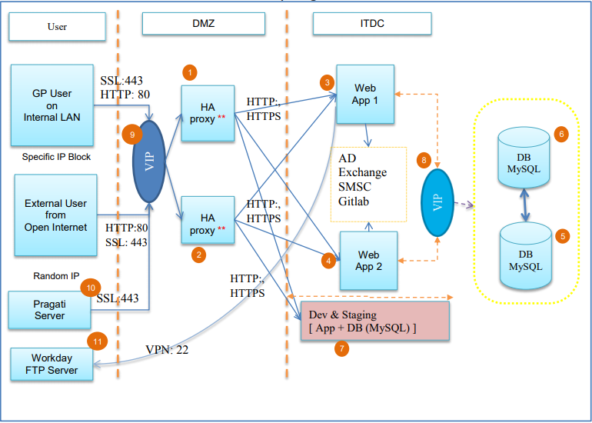

*Fig. 05: Server architecture for OneGP*

Following are the description of numbers at server architecture figure #05.

1. Porxy + Load balancer
2. Porxy + Load balancer
3. App/web server
4. App/web server
5. DB primary
6. DB standby
7. Dev + Staging server
8. VIP: Virtual IP between DB
9. VIP: Virtual IP between LB
10. Pragati VM
11. Workday FTP Server

### **Technical Standards**

|  |  |  |
| --- | --- | --- |
| **Technology** | **Database** | **Server** |
| Apache | MySQL DB | Apache |
| PHP |  |  |
| CakePHP3 |  |  |
| MVC |  |  |
| HTML5/CSS/Bootstrap |  |  |
| JavaScript/JQuery |  |  |

*Table 08: Technical Standard*

### **Page Controls**

|  |  |
| --- | --- |
| **Control Name** | **Description** |
| Date picker | select a date range |
| Label | Text Information |
| Button | Action to populate table data |
| Table | To display the report data |
| Hyperlink | To open new window or upload excel file |
| Dropdown | to populate list of data |
|  |  |

*Table 09: Page controls*

# **Traceability to Requirements**

List traceability information to trace the requirements from RS document to Design document.

The locations of design specifications should be mapped to the corresponding locations of the requirements in the RS document.

|  |  |  |
| --- | --- | --- |
| **Document reference Id & Description: (Doc Id from which this document is derived)** | | |
| **Sl No.** | **Reference document**  **Requirement/Feature (Section ID/Name)** | **Design document**  **(Section ID/Name)** |
|  |  |  |

# **Others**

Describe other items like reusable components etc.

# **Acronyms and Glossary**

|  |  |
| --- | --- |
| DMZ | Demilitarized Zone |
| HA | High-availability |
| ITDC | IT Data center |
|  |  |
|  |  |
|  |  |
|  |  |
|  |  |